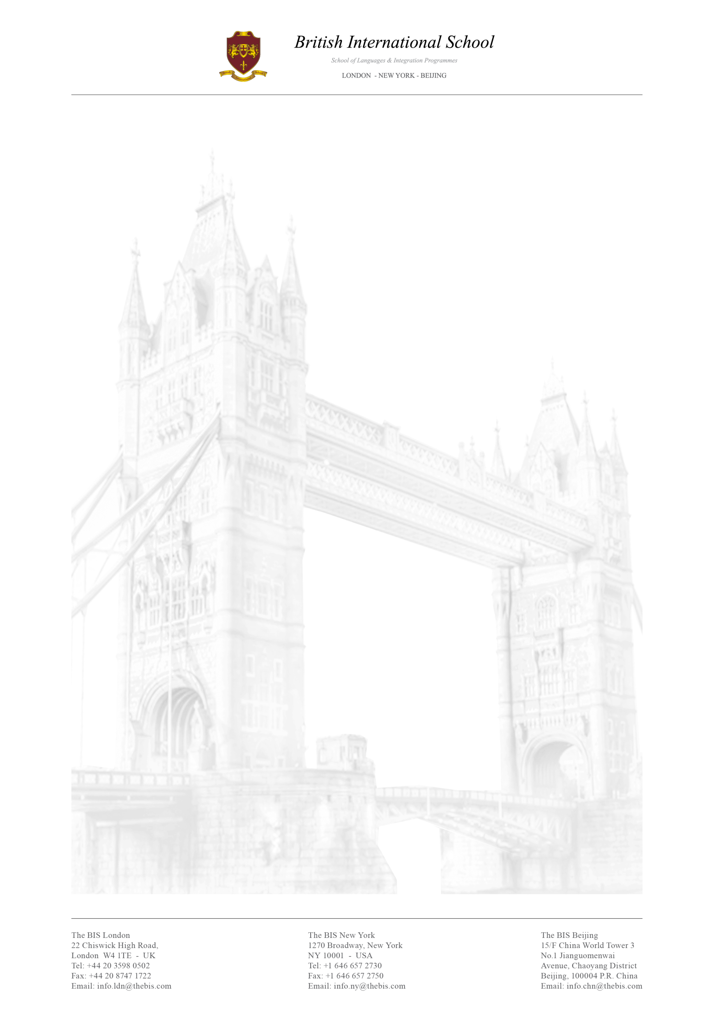

Tourism Department Internship

The British International School provides outstanding English language education to students in London, New York and Beijing. Our mission is to meet the diverse needs of a constantly evolving market. The British International School is always looking for highly motivated and talented individuals to join our team and put their knowledge into practice.

Here is a brief description of the internship possibilities:
In the Tourism Department, the intern will be in charge of looking after incoming groups of students, taking them around London during their school holidays ensuring they visit the city safely. Hence, interns can improve their skills in the tourism management field. A further advantage is that our interns receive unique training from actor Gary Fordham, who is the BIS official training supervisor for China, Russia and Europe.

The intern may also be assigned to any other BIS department according to the company’s needs for a short amount of time. Consequently tasks can be:
- Analysing and researching the target market
- Working at our Call Centre, contacting prospective customers
- Collaborating within the French Department to create programmes and liaise with the BIS Travel Agency and other departments in order to book activities and programmes
- Planning and setting up new strategies to enhance the partnerships with agents
- In the Studies Department, the individual will assist the Director of Studies in the organisation of English classes in our school.
- In our Finance Department interns assist in Business planning, make and receive external and internal payments, verify the company’s cash flow figures, manage and update financial statements.
- Within the Travel Agency interns will deal with programme planning, make and confirm bookings, liaise with suppliers, including accommodation, restaurants, tour guides and activity centres.

The assignment to each position will depend on the duration of the internship, availability of positions and needs of the company. We are looking for motivated people with a background in Marketing, Business, Sales and Tourism.

This position is unpaid but interns have the opportunity to attend daily Business and General English classes free of charge with CELTA qualified teachers. Further advantages are the possibility to join our tours and activities throughout London as well as an international stimulating working environment.

Please feel free to send your CV to is.supervisor@thebis.com or/and hr.manager@thebis.com with the subject line: Tourism Department Intern

